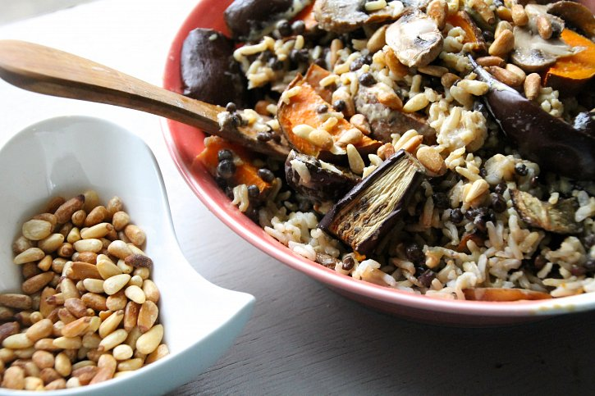

GALIC-TAHINI INFUSED BROWN RICE BOWL

**06 June 2015**

**There’s an awesome section in**[**my cookbook**](http://po.st/CooPL4)**called ‘ The Balance Bowl’ this is my way of creating an incredibly nutritious and delicious meal with ingredients you have lying around in the house. There’s 5 categories to fulfil and then an awesome dressing to make it as delicious as possible! I was recently filming a few videos with Tonic youtube, and made this incredibly yummy dish as an example of how to make a bowl of balanced goodness and it was just so delicious, so I knew i needed to share it with you all too! It’s a mixture of brown rice, lentils, roasted sweet potato, aubergine, mushrooms, toasted pine-nuts all drizzled in a garlic-tahini dressing (which is about my favourite thing - ever!).**



[**Pre-order my cookbook, and learn how to make your own balance bowl HERE!**](http://po.st/CooPL4)

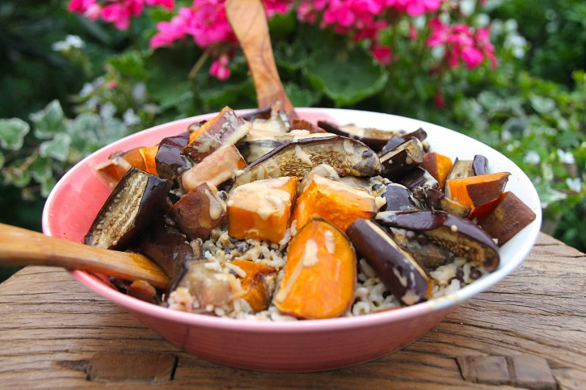

**NOTE: The brown rice & lentils below are pre-prepared. I buy them cooked, to save time for a quicker recipe. Make sure when you buy grains and pulses cooked they do only contain 1-3 ingredients; The whole food itself, a pinch of salt and a little olive oil. If you’d prefer to cook yours boil them as directed.**

RECIPE (SERVES 1)

INGREDIENTS

**1 cup of cooked brown rice**

**1 cup of cooked beluga/puy lentils**

**1 sweet potato, pealed and cubed**

**1 aubergine, sliced into cubes**

**a dozen button mushrooms, pealed and sliced**

**A good handful of pine-nuts**

GARLIC-TAHINI DRESSING

**1 tablespoon light tahini**

**1 tablespoon olive oil**

**1 tablespoon tamari**

**Juice 1 lemon**

**1/2 of 1 garlic clove, crushed**

METHOD:

**Pre-heat the oven to 190 degrees celcius. Start by preparing the mushrooms, sweet potato and aubergine as directed in the ingredient list. Add them to a roasting tray, drizzle with olive oil and a pinch of salt. Roast for around half an hour until cooked and soft (but not burnt!). The mushrooms may be completely done earlier than this so take them out and leave to the side whilst the rest cooks. Just before you take the other veggies out add the pennants to the tray to toast for around 4 minutes. Take them all out.**

**Meanwhile make the dressing by adding all ingredients to a bowl and mix really well!**

**To compile: Mix together all the ingredients and top with a generous amount of the dressing. e-voila! - A delicious, balanced meal.**

**- See more at: http://www.naturallysassy.co.uk/recipes/galic-tahini-infused-brown-rice-bowl#sthash.nWlh5F9V.dpuf**